**User Documentation**

Following user interfaces explain the functionalities of the system which are carried out by different uses of different user groups.

**Login Module**

**Login**

1. Enter the user name and password in relevant fields. (Figure C.1)
2. Click on the “Login” button.
3. If the user name and password are correct , display the main menu according to the assigned rights of the user.

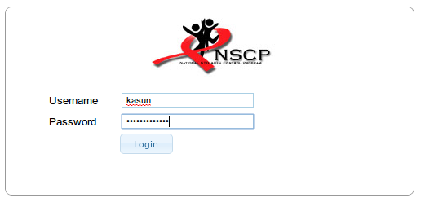**Figure C.1** Login form

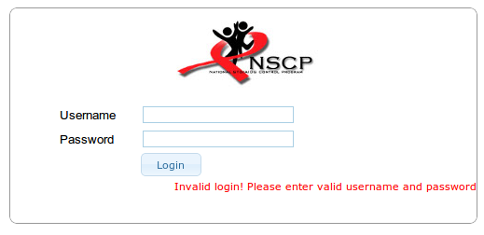**Figure C.2** Login form with wrong password

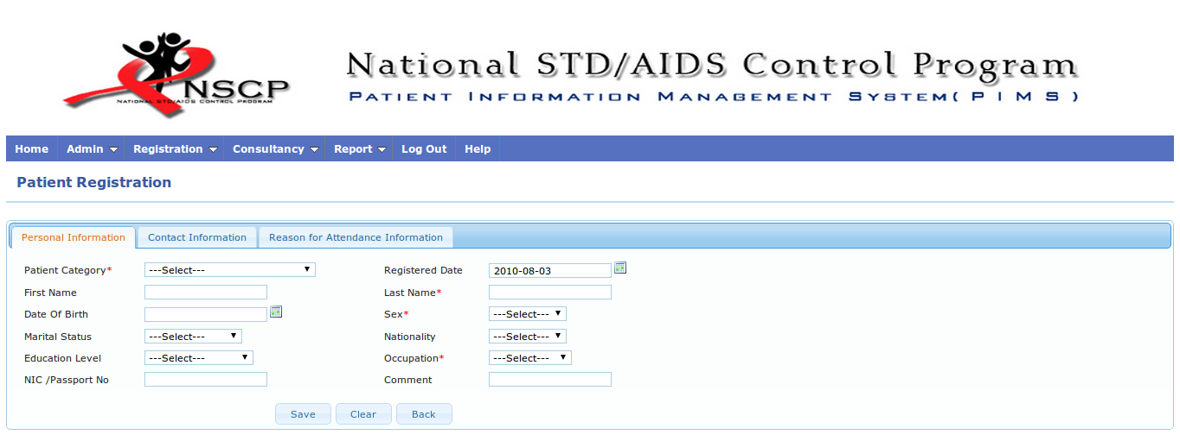

**Figure C.3** Successful login to the system.

**Admin Module**

1. Create User Groups
   * Select “Users->User Groups” menu option in the “Admin” menu.
   * User group creation page will be displayed once clicked on the “Add” button in user groups list page. (Figure C.4)
   * Enter the group name and description. (Figure C.5)
   * Click on the “Save “ button to save the data .
   * 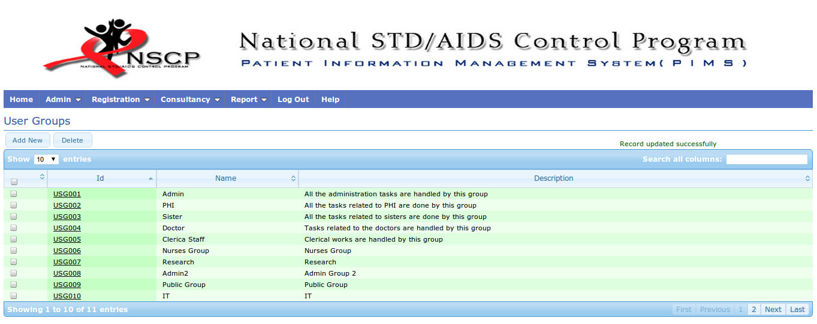Click on the “Back” button to go to the user groups list page

**Figure C.4** User group list

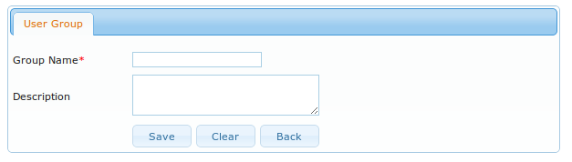**Figure C.5** User group creation page.

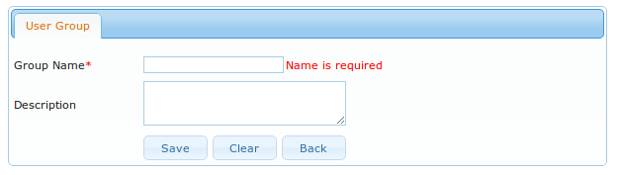

**Figure C.6** Empty group name

1. Edit User Groups

* User groups list will be displayed once selected the “Users->User Groups” menu option in the “Admin” menu.
* Edit view is displayed after clicking on the relevant user group id link in the list. (Figure C.7)
* Change the required data.
* Click on the “Save” button to save the changes.

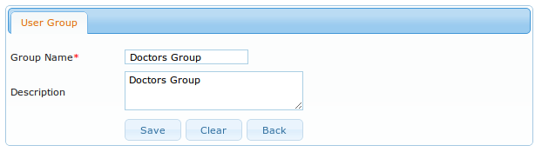

**Figure C.7** Edit view of a user group

1. Delete User Group

* User groups list will be displayed once selected the “Users->User Groups” menu option in the “Admin” menu.
* Select the check box/s of user group/s which need to be deleted.
* Click on the “Delete” button.
* Click on the “Ok” button in the confirmation dialog box for deleting the record/s.

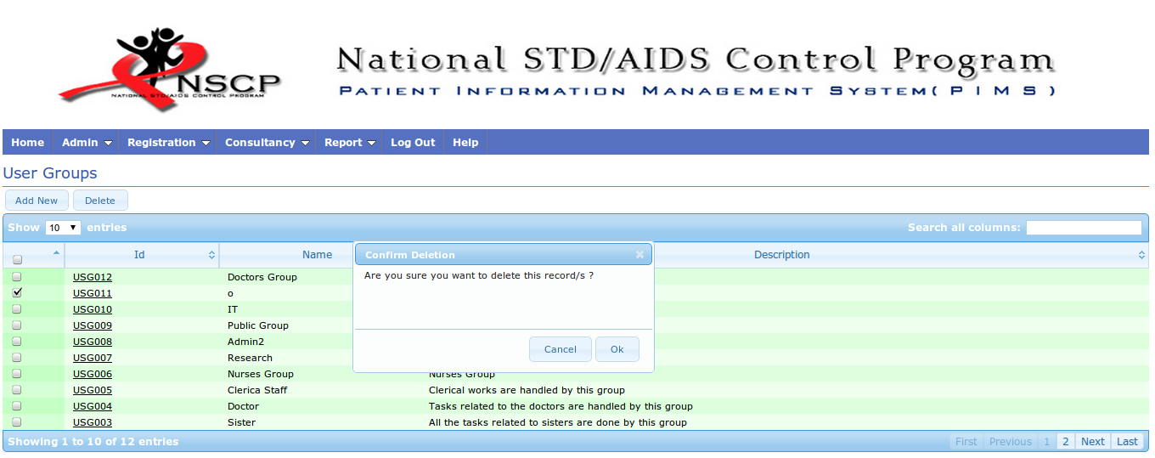

**Figure C.8** Delete an user group

1. Search User Group

* User groups list will be displayed once selected the “Users->User Groups” menu option in the “Admin” menu.
* Type search value in the “Search all columns**”** text box.

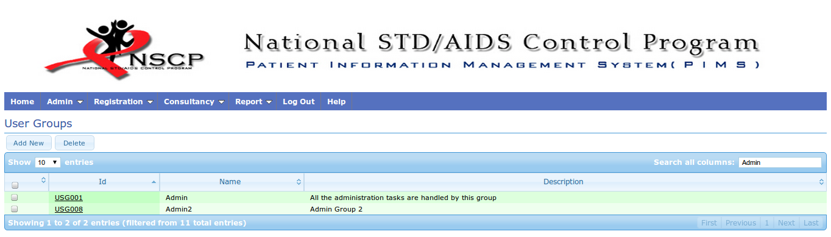

**Figure C.9** Search user group

1. Create User Accounts

* Select “Users->User Accounts” menu option in the “Admin” menu.
* User account creation page will be displayed once clicked on the “Add” button in the user accounts list page (Figure C.10)
* Enter the required data.
* Click on the “Save “button to save the data.
* Click on the “Back” button to go to the user accounts list page.

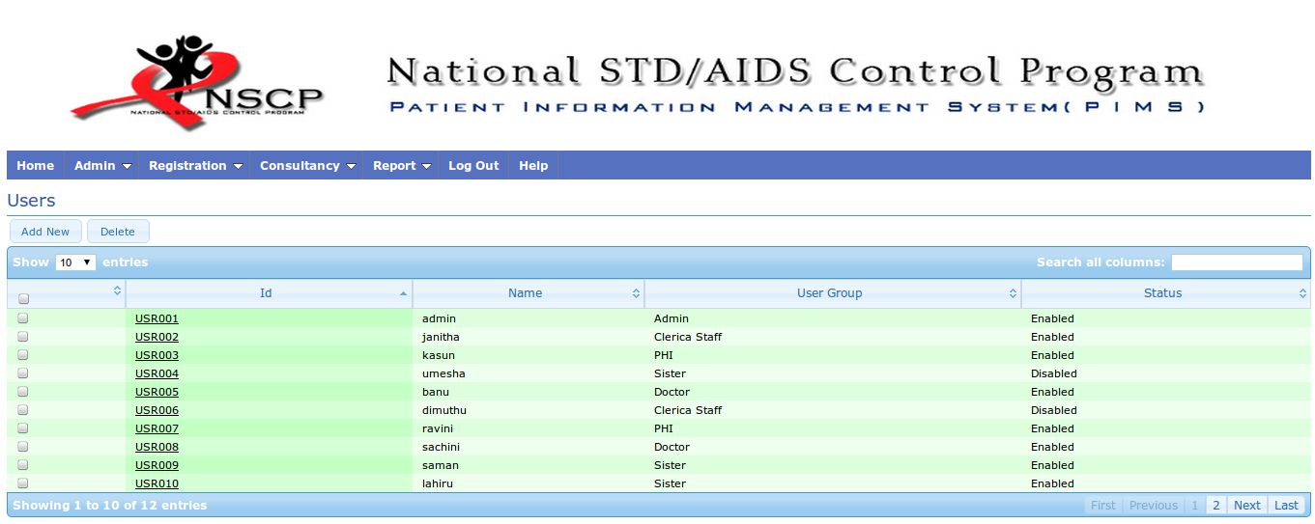

**Figure C.10** Users List

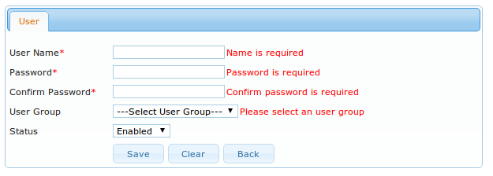

**Figure C.11** Invalid data entered for the fields.

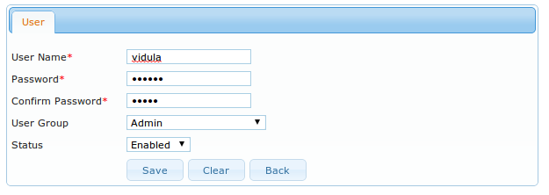

**Figure C.12** Fields with proper data.

1. Assign Rights for User Groups

* Select “Users->User Groups” to open the user groups list (Figure C.4).
* Click on the user group id link which has to be assigned rights.
* Click on the “Assign Rights” button .
* Select the module from the “Module” drop down list.
* Select the required options from “Add, Edit, Delete, View” to assign (“View” is a must for any module).
* Click on the “Save” button to save the data.

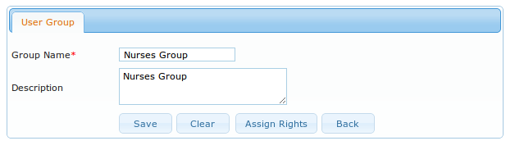

**Figure C.13** Click on the assign button to add user rights.

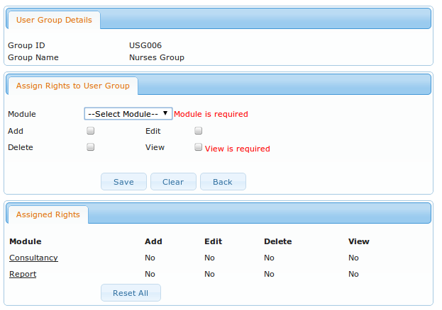

**Figure C.14** Compulsory field’s validation.

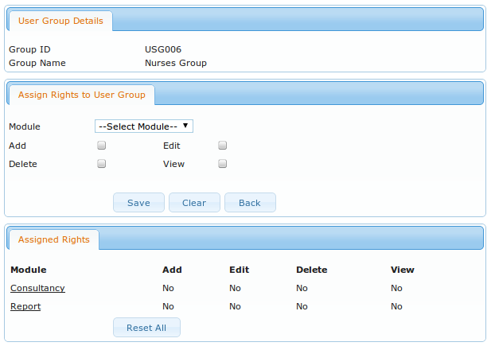

**Figure C.15** Before assigning a module.

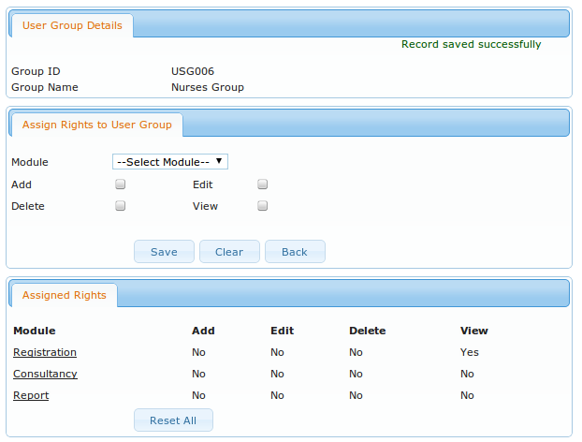

**Figure C.16** After assigning a module.

1. Reset All Assigned Rights

* Click on the “Reset All” button in the “Assigned Rights” area.
* Click on “Ok” button in the confirmation dialog box for resetting all the rights.

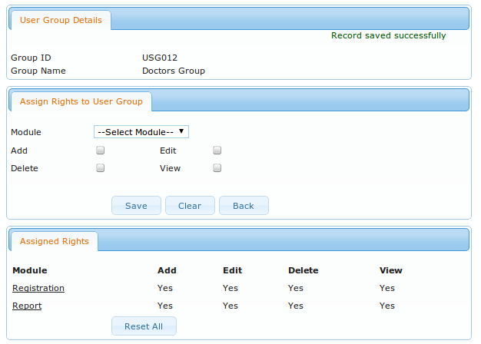**Figure C.17** Before resetting the rights.

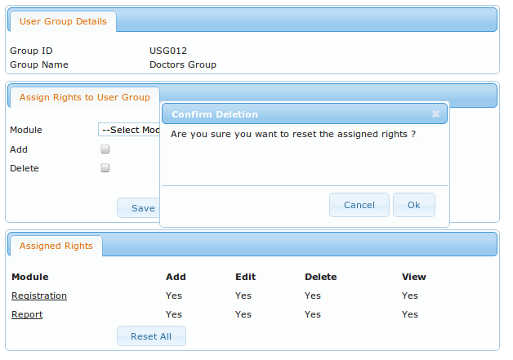

**Figure C.18** Get the confirmation before resetting the rights.

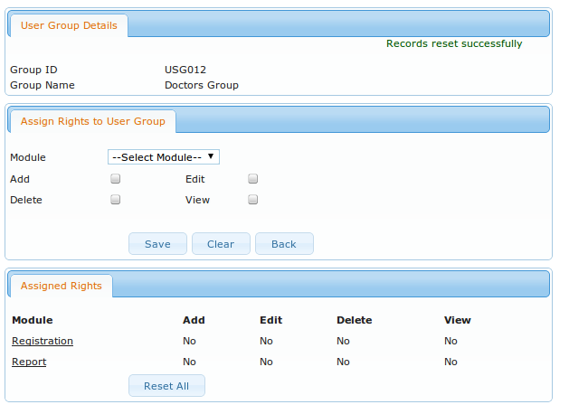

**Figure C.19** After resetting the rights.

**Registration Module**

1. Patient Registration

* Click on the “Patient Registration” in “Registration” menu
* Click on “New Patient “button in the patient registration page.
* Click on the “Personal Information Tab” for entering personal data.
* Click on the “Contact Information Tab” for entering contact details.
* Click on the “Reason for Attendance Information Tab” for entering attendance reasons.
* Click on the “Save” button to save data.

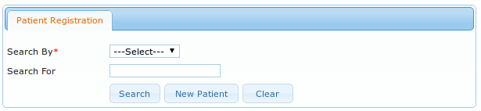

**Figure C.20** Select “New Patient” for patient registration form.

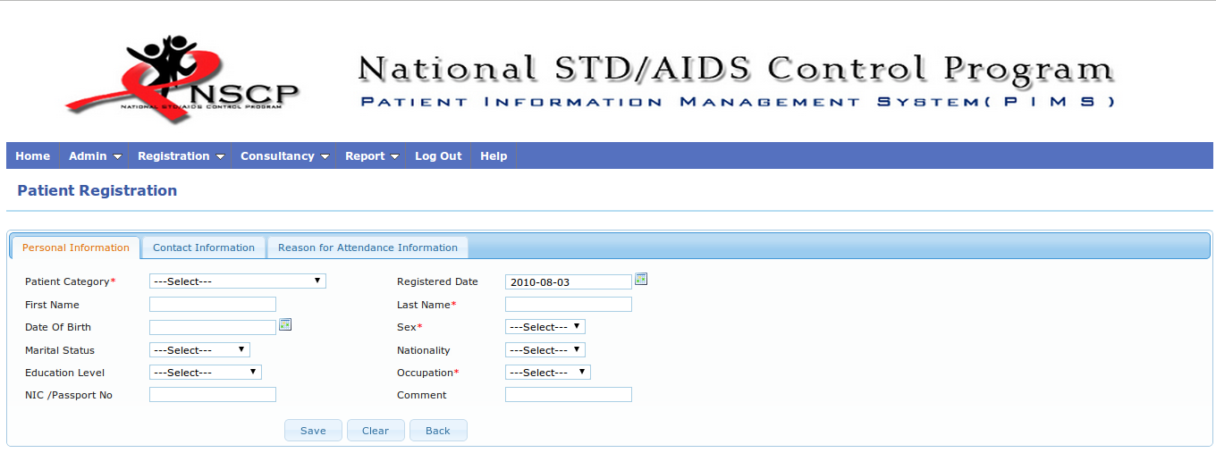

**Figure C.21** Main registration form.

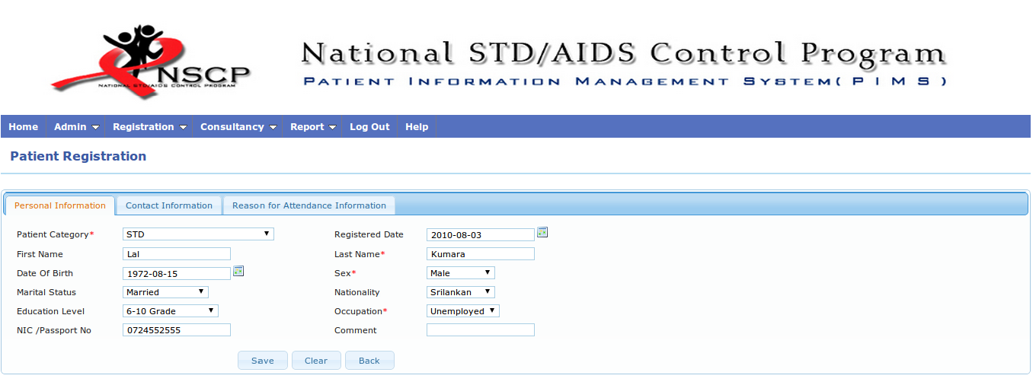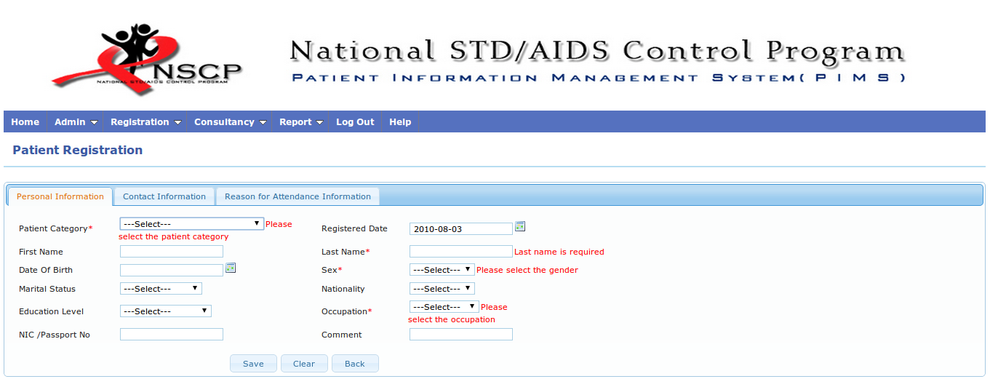**Figure C.22** Validation of registration from.

**Figure C.23** Registration form with data.

1. **Edit Patient Information**

* Click on the “Patient Registration” in “Registration” menu.
* Enter the patient no or name to search in the patient registration page.
* Click on the “Search” button.
* In the edit view, select the relevant tab for editing.
* Click on the “Save” button to save the data.

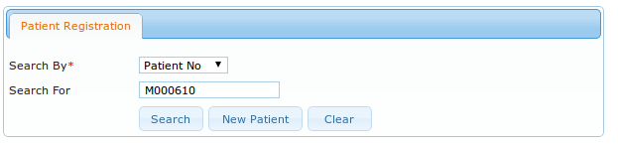

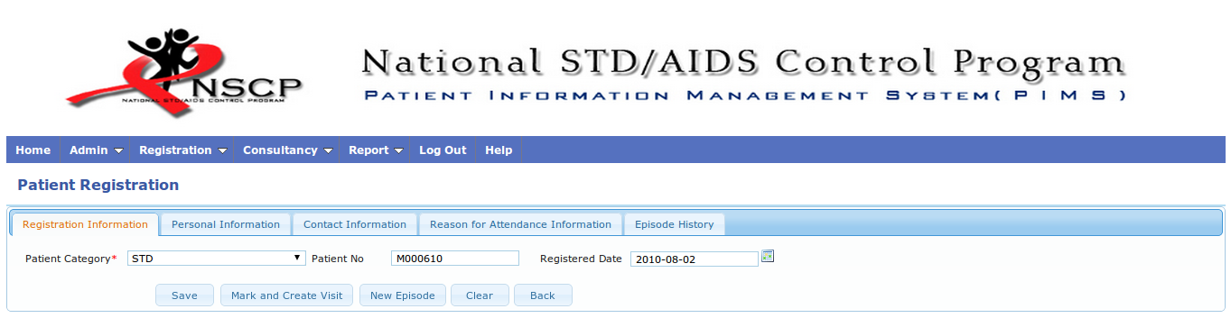**Figure C.24** Search a patient.

**Figure C.25** Edit view of a patient.

*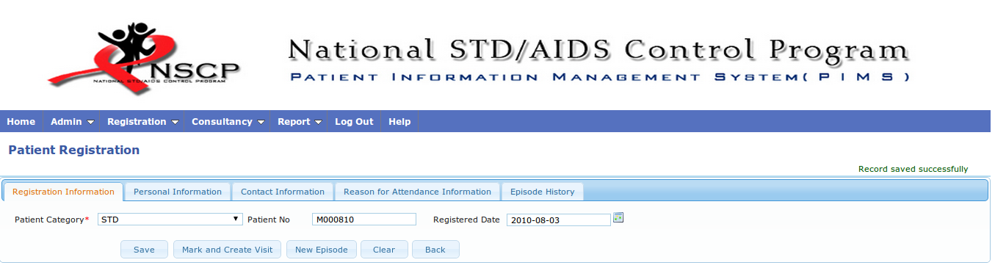***Figure C.26** Confirmation message of edited record.

1. Mark And Create Visit

* Select “Registration->Mark / Create Visit” menu option in the “Registration” menu.
* Enter the patient no in the search view.
* Click on the “Search” button.
* Click on the “Show Visits” link of an episode in episode history page.
* Enter appointment or visited date .
* Click on the “Save” button.

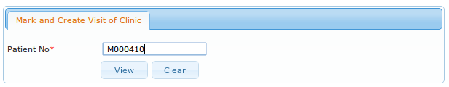

**Figure C.27** Search a patient for updating the clinic attendance records.

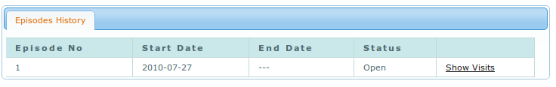**Figure C.28** Clinic visit records of episodes .

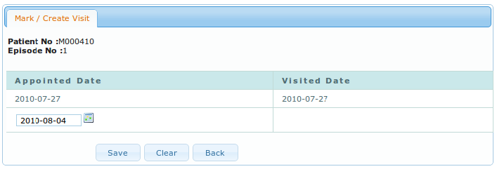

**Figure C.29** Update the clinic visit record .

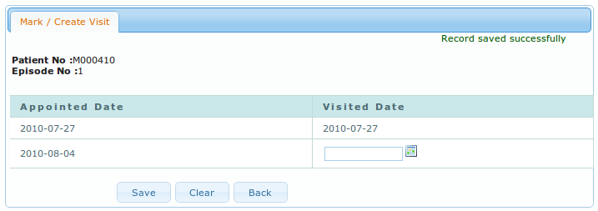

**Figure C.30** Updated the clinic visit record.

1. View Appointment List

* Select “Registration->Appointment List” menu option in the “Registration” menu.
* In the clinic appointment searching area , select date an the gender to be searched.
* Click on the “View” button.
* Click on the “Export” button to export the report.

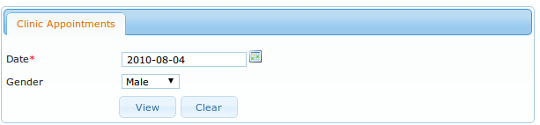

**Figure C.31** Search appointment list of a particular day.

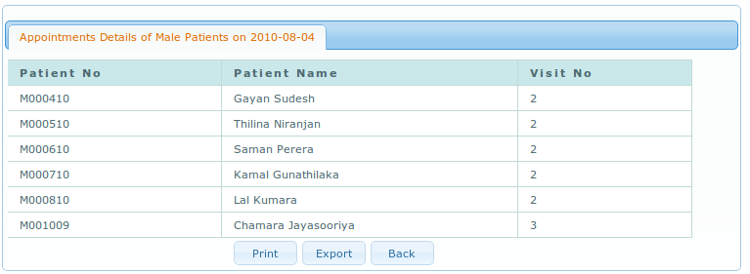

**Figure C.32** Appointment list.

1. **Create Patient Category**

* Existing category list will be displayed once selected the “Registration->Patient Category” menu option in the “Registration” menu (Figure C.38).
* Click on the “Add” button to open the category creation page.
* Enter the category name and description.
* Click on the “Save” button.

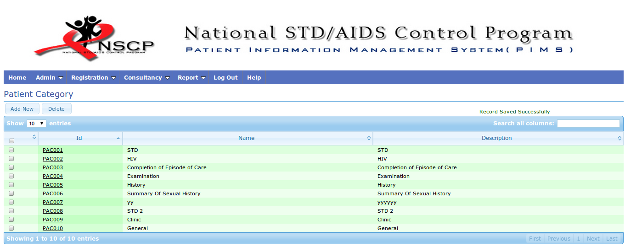

**Figure C.33** Category list of patients..

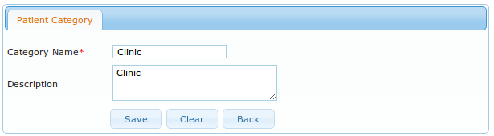

**Figure C.34** Add new patient category.

**Consultancy Module**

1. **Add STD Episode Care**

* Select “Consultancy->STD Episode “ in “Consultancy” modul**e.**
* Enter the patient no
* Click on the “Search” button.
* Click on the “Show Episode Care” link in episode details area.
* Select the relevant tab to add clinical records in the STD episode of care area.
* Add the clinical data.
* Click on the “Save” button to save data.

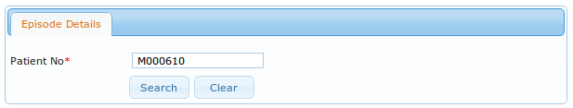 **Figure C.35** Search episode details of a patient.

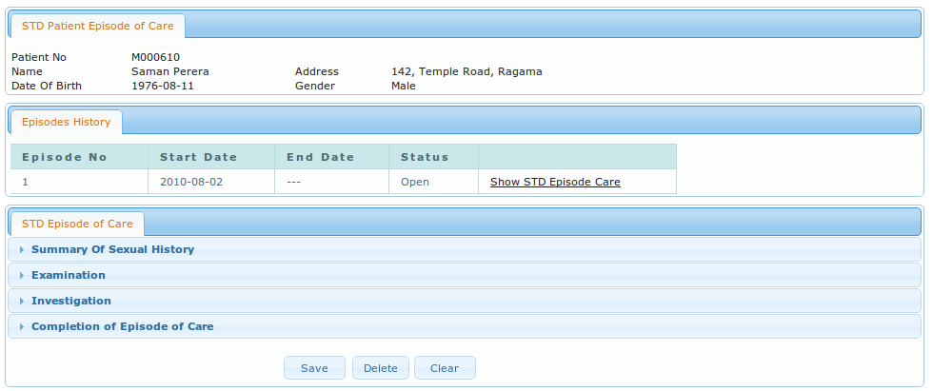

**Figure C.36** Episode details of a patient.

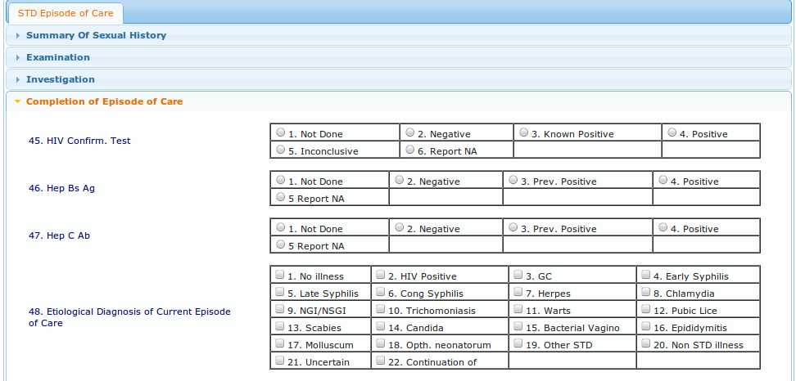

**Figure C.37** STD episode care details.

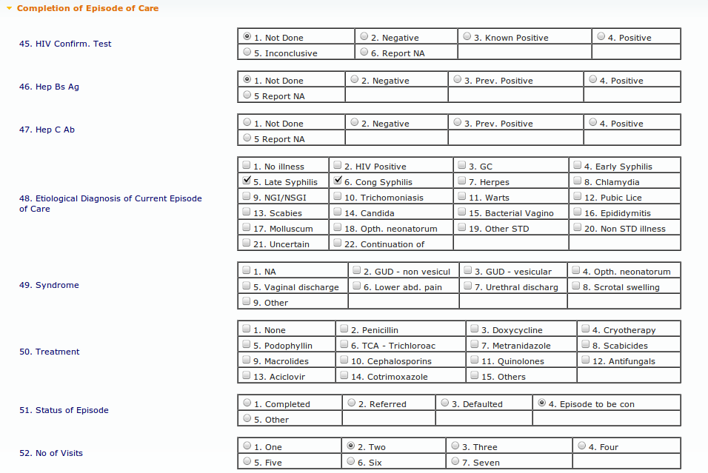

**Figure C.38** Updated STD episode care details.